PROJECTEXPO 2026
SMART WILD PIG DETECTION AND ALERT SYTEM USING IoT SENSORS

TEAM MEMBERS:
DHANYASRI J
LAVANYA V
ARUNACHALAM M
SUJITH N

INTRODUCTION:
Agriculture is one of the most important sectors that supports food production and the economy. However, farmers often face significant losses due to wild animals entering agricultural fields and damaging crops. Among these animals, wild pigs are one of the major causes of crop destruction because they feed on crops and trample fields, leading to reduced yield and financial loss.
Traditional methods such as manual guarding and fencing require continuous human effort, are time-consuming, and may not always be effective. With the advancement of the Internet of Things (IoT), it is possible to develop smart systems that automatically monitor agricultural fields and provide instant alerts when wild pigs are detected.
This project, "Smart Wild Pig Detection and Alert System Using IoT and Sensors," uses a PIR motion sensor and an ultrasonic sensor to detect wild pig movement near the farm. An ESP32 microcontroller processes the sensor data and activates a buzzer to alert nearby people. At the same time, the system sends a real-time notification to the farmer through an IoT platform, allowing quick action to prevent crop damage.
The proposed system is low-cost, energy-efficient, and easy to install, making it suitable for small and medium-sized farms. It helps farmers monitor their fields continuously without requiring constant human supervision. This project aims to improve crop protection and reduce agricultural losses through smart sensor technology and IoT-based communication.
Problem Statement:
Wild pigs frequently enter agricultural fields andcause severe crop damage, resulting in significant economic losses for farmers. Traditional methods such as manual guarding are time-consuming, labor-intensive, and cannot provide continuous monitoring. There is a need for an automated and affordable system that can detect wild pig movement and immediately notify farmers. This project proposes a Smart Wild Pig Detection System using IoT and Sensors. The system uses PIR and ultrasonic sensors to detect movement and distance. When a wild pig is detected, an alarm (buzzer) is activated, and an IoT notification is sent to the farmer. The system provides continuous monitoring, reduces crop damage, and improves farm security with minimal human intervention.
Abstract :
Wild pig intrusion is a major problem in agricultural fields, causing extensive crop damage and financial losses to farmers. Conventional methods such as manual guarding require continuous human effort and are often ineffective for protecting large agricultural areas. To overcome these limitations, this project presents a Smart Wild Pig Detection System using IoT and Sensors.
The proposed system consists of a PIR motion sensor, an ultrasonic sensor, an ESP32 microcontroller, a buzzer, and an IoT platform. The PIR sensor detects movement, while the ultrasonic sensor measures the distance of the approaching object to improve detection accuracy. The ESP32 processes the sensor data and identifies possible wild pig movement. Once the animal is detected, the system immediately activates a buzzer to alert nearby people and simultaneously sends a real-time notification to the farmer through an IoT platform or mobile application.
The proposed solution is affordable, energy-efficient, and easy to install in agricultural fields. It provides continuous monitoring without requiring constant human supervision. By combining sensor-based detection with IoT communication, the system enables farmers to respond quickly and reduce crop damage. The project offers a practical and reliable solution for protecting agricultural fields. In the future, the system can be enhanced by integrating cameras, artificial intelligence, GPS tracking, or solar power to improve its performance and coverage.

Objectives:
- To detect wild pig movement using PIR and ultrasonic sensors.
- To continuously monitor agricultural fields.
- To activate a buzzer when wild pig movement is detected.
- To send real-time notifications to farmers using IoT.
- To reduce crop damage through an automated monitoring system.
- To develop a low-cost and energy-efficient solution.

Expected Outcomes:
- Accurate detection of wild pig movement.
- Automatic activation of the buzzer upon detection.
- Real-time IoT notifications to farmers.
- Reduced crop damage and financial losses.
- Improved farm monitoring and security.
- Low-cost, reliable, and easy-to-use system.
Literature Survey:
S.No | Author(s) & Year | Title | Technology Used | Key Findings | Limitations
1 | Divya et al. (2018) | IoT-Based Wild Animal Intrusion Detection System | PIR, Camera, GSM | SMS alerts | False alarms
2 | Alui& Mohamed (2023) | Animal Intrusion Monitoring | PIR, Camera, Blynk | Real-time monitoring | No species ID
3 | Abraham et al. (2023) | Review of Intrusion Systems | IoT, GSM | Reviews methods | No new system
4 | Miao et al. (2023) | Fog-based Agriculture | LoRa, Camera | Low latency | Complex
5 | MDPI (2025) | YOLOv8 Surveillance | Raspberry Pi, YOLO | High accuracy | High processing
6 | Joshi et al. (2025) | Wild Boar Detection | YOLOv8, GSM | Auto deterrent | Expensive
7 | Ninan et al. (2026) | AI Wild Boar Detection | Thermal, YOLO | Instant alerts | Training needed

Existing Solutions Analysis:
S.No | Existing Solution | Technology Used | Advantages | Limitations
1 | IoT-Based Wild Animal Intrusion Detection System | PIR Sensor, Camera, GSM | Sends SMS alerts and detects movement | False alarms; no species identification
2 | Animal Intrusion Monitoring System | PIR Sensor, Camera, Blynk | Real-time monitoring | Cannot identify specific animal species
3 | Review of Intrusion Detection Systems | IoT, GSM | Summarizes methods | No practical implementation
4 | Fog-Based Agriculture Monitoring | LoRa, Camera | Low latency | Complex and costly
5 | YOLOv8 Surveillance System | Raspberry Pi, YOLOv8 | High accuracy | High processing requirement
6 | Wild Boar Detection System | YOLOv8, GSM | Automatic detection | Expensive
7 | AI-Based Wild Boar Detection | Thermal Camera, YOLO | Accurate alerts | Costly hardware

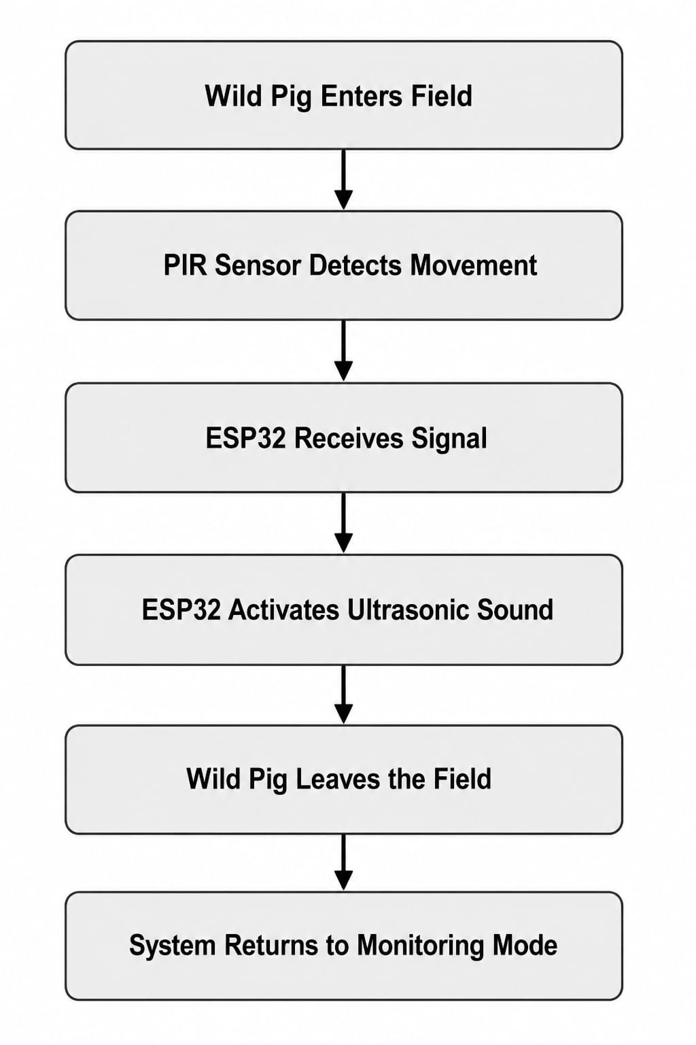
Gap Analysis:
S.No | Research Gap Identified | Proposed Solution in Our Project
1 | False alarms due to motion-only detection | Use ESP32-CAM with PIR verification
2 | AI systems require powerful hardware | Use low-cost ESP32 without AI
3 | High implementation cost | Affordable prototype
4 | Only monitoring, no deterrent | Automatic ultrasonic deterrent
5 | Needs continuous internet | Standalone operation
6 | High power and maintenance | Compact low-power ESP32
7 | Difficult for rural deployment | Simple portable design

REFERENCE:
- K. Ashton, "That 'Internet of Things' Thing," RFID Journal, 2009.
- Bahga and V. Madisetti, Internet of Things: A Hands-on Approach, Universities Press, 2015.
- Raj Kamal, Internet of Things: Architecture and Design Principles, McGraw-Hill Education, 2017.
- S. Madakam, R. Ramaswamy, and S. Tripathi, "Internet of Things (IoT): A Literature Review," Journal of Computer and Communications, 2015.
- IEEE Xplore Digital Library – Research papers on IoT-based smart agriculture and wildlife monitoring.
- Springer Nature – Research articles on sensor-based agricultural monitoring and smart farming.

